**Ideation Phase**

**Define the Problem Statements**

|  |  |
| --- | --- |
| Date | 18 June 2025 |
| Team ID | LTVIP2025TMID35513 |
| Project Name | pattern sense: classifying fabric patterns using deep learning |
| Maximum Marks | 2 Marks |

**Customer Problem Statement Template:**

I am **a textile manufacturer, fashion designer, or fabric retailer** who works with a large variety of fabric patterns.

I’m trying to **efficiently and accurately classify fabric patterns into different design categories (such as floral, geometric, abstract, etc.) in order to automate inventory management, support design selection, and improve customer recommendations**.

But **the current manual process of inspecting and categorizing fabric patterns is slow, subjective, and requires skilled labor, leading to errors and inconsistencies**.

Because **there is no intelligent, automated system that can accurately recognize and classify fabric patterns from images at scale using advanced AI and deep learning methods**.

Which makes me feel **frustrated by inefficiency, limited in scaling operations, and unable to deliver personalized and modern experiences to customers**.

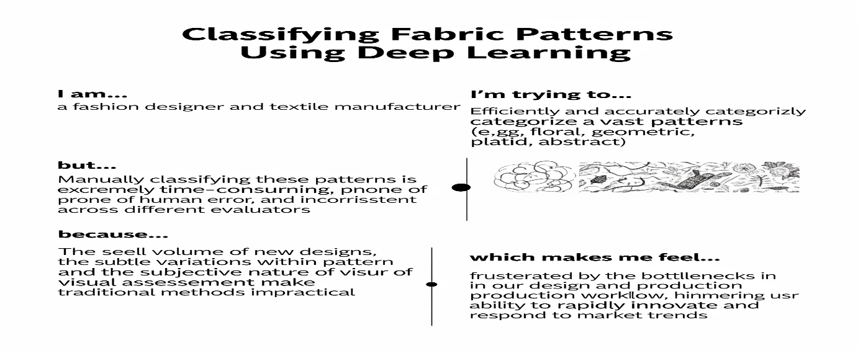

| **Problem Statement (PS)** | **I am (Customer)** | **I’m trying to** | **But** | **Because** | **Which makes me feel** |
| --- | --- | --- | --- | --- | --- |
| PS-1 | A textile manufacturer | Automate the classification of fabric patterns to improve inventory and production efficiency | Manual classification is slow and inconsistent | There is no AI-based system capable of accurately recognizing and classifying complex fabric patterns | Frustrated, limited in scalability, and inefficient |
| PS-2 | A fashion retailer or designer | Recommend designs to customers based on their pattern preferences | Current methods lack precise, automated pattern categorization | There is no advanced deep learning solution to identify pattern types reliably | Unable to provide personalized experiences and competitive service |